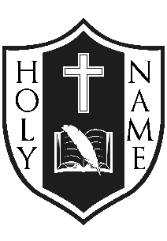
Holy Name
Catholic School
October, 2019
Greetings
There are so many blessings to give thanks for and during this month of Thanksgiving, I offer you this reflection:
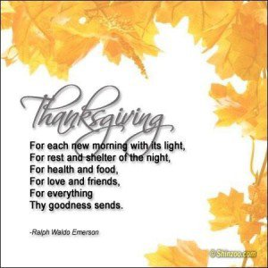
God Bless, Mrs. McD.
Mrs. Lisa McDonald, Principal

The first school Mass took place on Fri. Sept. 20, 2019 and was a celebration that focussed on “new beginnings” and welcoming everyone back to a new school year. Staff from Holy Name served the ministries at this Mass. The next school Mass is scheduled for Thurs. Oct. 24 at 9:30 AM and the theme for the mass will be

“Thanksgiving”; please join us if you can at Holy Name of Jesus Catholic Church.
Caring and Safe Schools:
EarlyON Program: All parent and caregivers with children 0-6 years are invited to attend each Monday 9:30 – 3:30 and Wednesday 9:30 -12:30. Activities include sensory play, creative art, group experiences and fitness during gym times (9:30-10:45 & 11:40-12:20). Don’t forget indoor shoes! Bring your lunch and stay for the full day every Monday!
Annual Terry Fox Walk: Mrs. Cross and Ms. Devlin along with committee members from Gr. 7 and 8 demonstrated great leadership for this event. Thank you to all who made donations to the Canadian Cancer Foundation. A total of $1428.00 was raised! Faith in Action: Live It was evident! 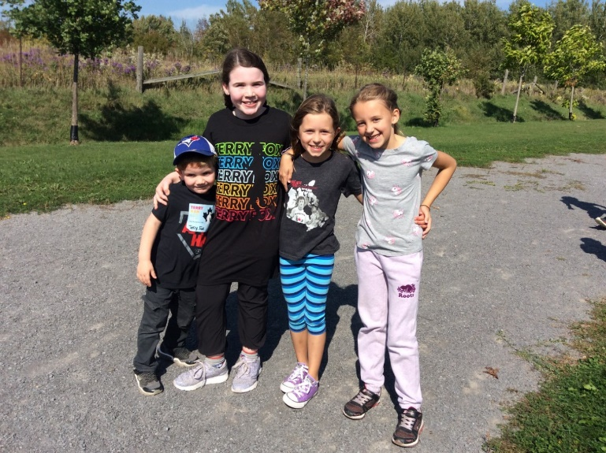
Catholic School Council Update
The Annual Welcome Back Corn Roast and School Open House was a great success! The Bouvier family won the turkey donated by Barriefield Meats. Superintendent of School Effectiveness, Theresa Kennedy, won the 50/50 draw and returned the full prize money back to the CSC! Many thanks to the Catholic School Council for their planning and organization! Faith In Action: Live It.
The Holy Name Catholic School Council Team for this school year includes: Chairperson: Lindsay Bourque, Treasurer: Lesley Petras, Secretary: Malissa Sheridan, Fundraising Lead: Alana Todd, Community Representative: Francine Oosterman, and Nikki Irwin as the CAPCE Representative.
Meeting Minutes are posted on the school website each month. All parents are invited to attend the next meeting on Wed. Oct. 16 beginning at 6:30 PM.
EQAO: The EQAO results for last year’s Primary and Junior Assessments can be reviewed at www.eqao.com. In Reading, 69% of Gr. 3 students performed at Level 3 and 4, a slight decline from the previous year. In Writing; 100% achieved at or beyond the provinicial standard which is an increase of achievement. In Mathematics a similar score to the previous year of 69% was the result. Gr. 6 results showed continued strength in Reading with 100% of students at or above the provincial standard. Junior Writing results were also outstanding at 100%. The Junior Mathematics results exceeded both the Board and provincial results with 73% achieving at Level 3 or 4. Mathematics remains a provincial, board and school focus. Holy Name’s 2019-20 School Improvement Plan for Student Achievement & Well-being (SIPSA-W) will continue to focus on the enhancement of Mathematics as well as aim to strive for continued excellence in Language (Reading and Writing).
Digital Portfolios- FreshGrade: Its purpose is to help students achieve their personal goals and become competent, successful and contributing members of society. Students in Kindergarten to Gr. 6 will continue to create digital portfolios using FreshGrade which allows students and staff to upload learning artifacts to share with families. The artifacts will serve to start a converstation with families about their child’s learning. Parents are able to offer feedback to children about their learning and interests. Consent Forms need only to be done if a student is new to Holy Name, this year.
Music Lessons: Carol Kenny is offering piano, ukelele and voice lessons again this year. Lessons will be available on Thursday afternoons. If interested, contact Carol @ 613.572.3000.
Sports Update:
Holy Name has a Junior Boys and Junior Girls Soccer Team as well as a Senior Co-ed Team. The system tournaments have been postponed and coaches will inform team members of the new dates once they are known. Thank you to the coaches for their time and support: Mr. Rooney, Mrs. Mackler and Volunteer Coach, Samer. Volleyball try-outs will be coming up next!
Upcoming Events:
Aim to track the happenings of Holy Name on our School’s Webpage.
School Photos: Wed. Oct. 23, 2019.
ECO SCHOOL

“E-NEWS”: If you have not already done so, please sign up to receive the monthly School Newsletters via email, please complete the sign up section on the school’s webpage. From this month moving forward, all monthly Newsletters will be posted on the school’s webpage. School events will be listed on the calander as well. Thank you for helping us with our ECO efforts.

TWITTER: Follow us @alcdsb_name.
POPCORN: Popcorn is sold on Wednesdays and Fridays for $1.00 This treat meets the provinicial nutritional value and helps to subsidize school funds for excursions and bussing.

